**Web Development – Reflective Essay on Group Assignment**

**Summary**

The main objective of this essay is to sum up my overall experiences, frustrations and lessons learnt from the assignment. As this essay is based on my personal perceptions, the language is prone to be biased and reflect upon my individual circumstances; however, every effort has been made to be as fair and objective towards my team members as much as possible.

Additionally, it is important to bear in mind that - at the time of writing - the project is not completed yet; however, I feel it is prudent to sum up my experiences now as my role in the team assignment is pretty much concluded, other than general check-ups and team monitoring on Slack.

**Prior Web Development Experience**

Prior to taking this course, I had no formal web development experience beyond dabbling in simple HTML as a high school / university student. As an amateur writer who posted short stories to various online communities, I required some basic knowledge of formatting and how HTML tags were used in order to promote my work across various platforms. Moreover, I was also a blogger and a bit of know-how in that area helped me to customise the layouts of my blogs.

Beyond that, I also gained some practical knowledge of how web development works as a software testing / software engineering professional. Throughout my career, I have worked with CSS selectors in order to write automated end to end tests for various applications; I have also written code for the scraping of websites that also required knowledge of selectors.

As a conclusion, my main experiences in web development in the past never included any building of websites and, as such, this group assignment was my first real foray into CSS stylesheets and using HTML on a larger scale than editing a paragraph or two.

**Team Reshuffle – Effects and Influence**

Before being assigned to my current team, I was part of another one that included Anastasia Kashkinova with whom I collaborated during this process. The other members of that original team never responded. Before the team reassignment took place, we had already done a significant amount of work and were well on our way to completing the CSS for the theme park website.

Consequently, I was reluctant to let go of the work that I had started and asked Anastasia if it would be fine to keep the theme park idea and my previous work associated with it. This previous work included two reviews of other parks, the HTML coding of all three pages and the text content associated with these pages. I also took a stab at the initial CSS design of the site by writing a style sheet which I applied to all three pages.

Anastasia was responsible for the wireframes and greatly improved upon the stylesheet by adding a banner and customising the colour scheme for the layout. She also improved upon the navigation and look of the footer. She redesigned the CSS for the first page, which was to be a starting point for making the CSS on the remaining two pages look more professional.

After the reshuffle, I asked Anastasia if it was fine to keep the banner and her design for the index page which she kindly agreed to. The idea was to use her design as a prototype for how the rest of the website should look in terms of style.

**Theme Park in the Woods Content – Before the Reshuffle**

I have always been fascinated by the horror genre, especially gothic horror which offers a fascinating insight into the human psyche and social boundaries. Despite this fascination, however, I am something of a scaredy-cat and have never set foot inside a haunted house. I think this is mainly because I do not enjoy cheap thrills and have something of a weak constitution that would cause me to probably faint in a place like that.

Anyhow – irrespective of these fears – I immediately latched upon the idea of a horror themed park. The reason for that is because the idea does not seem to be as generic as a family theme park, and I wanted to have the opportunity to insert some bad puns into the website.

Luckily, Anastasia was quite open to my ideas and helped me flesh them out further in order to transfer them to a working web site. She was the one who suggested having VR as one of the attractions rather than making everything based around it.

Once the outline for the theme park was decided upon, I started writing the content for all the pages. By the time the team reshuffle took place, I had written about 70 % of the page content for the website. To the best of my knowledge, the content written on these pages is entirely mine and thus original work.

**Theme Park in the Woods – After the Reshuffle**

I was fortunate enough to have my current team members be receptive with taking my old theme park idea on board. I especially credit Annie and Iloise for helping me flesh out the web content even more by reviewing additional theme parks, contributing ideas to the structure of the page and designing the wire frames.

While writing the webpage content, I consciously tried to insert bad puns that would remind future visitors of the bad jokes that villains like Freddy Kruger often employ. I also tried to insert as many popular references to horror-based franchises as I could. Indeed, the name of the theme park is a reference to a 2011 horror film called ‘Cabin in the Woods’.

**HTML**

The HTML that I wrote mainly consisted of paragraph tags, h1 or h3 headers and unordered lists. This was so that the content could be displayed in an effective way. I also tried to be consistent with how I formatted the HTML tags; I also tried to ensure that the HTML files had comments where they were necessary.

Upon the suggestion of Annie, I decided to add an embedded map into the index page that showcased where the fictional theme park is located. I also incorporated suggestions from Iloise and Annie to include a price list as well as more detailed descriptions of the hotel rooms available. I also altered the HTML where necessary so that they fit in with the updated wireframes.

**CSS and Wireframes**

Any CSS contributions on my part were simplistic and served more as a prototype than any attempt at a more completed project. Moreover, once Anastasia was no longer working with me as a teammate, I found myself in the awkward position of not being able to use Figma as she had done - at least, not as well.

After some fruitless attempts at trying to design wireframes using various online tools and PowerPoint, I gave up and just drew some simplistic ones using Paint. Thankfully, Annie and Ilosie both contributed wireframes that are much better than my shoddy attempts.

Upon receiving feedback from fellow students, Will expanded upon the CSS I initially worked on by adding more features and improving the functionality of it (e.g. animation).

**GitHub Organisation**

In order to facilitate changes and any suggestions made by other team members of the group, I moved the existing work into a GitHub organisation that only members of the team have access to. I also helped other team members gain access to the repository.

**Peer Reviews**

So far, the peer reviews have been constructive and served as good pointers on what to improve upon. In particular, the peer reviews have highlighted just how much the CSS and wireframes needed to be updated and further enhanced. I tried to share whatever feedback I got with the rest of the team in order to improve our project.

**Weekly Meetings**

Upon joining the team, William and K.M took charge of the meetings and found a way to get most of us together despite our very differing time zones. William also produced a list of discussion points / agendas for each meeting. Will always brought ideas on board, communicated any points with others and took charge of the project during the final stages.

During the time of writing, we are still in the process of finalising the project and coordinating how Will shall enhance/refine the CSS further. Annie has also agreed to update the wireframes.

**Final Verdict**

As there is only week left before the final deadline, I cannot comment on how successful this teamwork venture is as an overall effort. Overall, I felt that there was too much radio silence at times and that work should have started a lot earlier. Personally, I feel that incremental work throughout a longer span of time is more effective than ramping up major efforts more closely towards a tight deadline.

However, I am also mindful of the fact that not everyone works as quickly as I do or prioritises getting work done in advance. I will admit that it is hard for me to understand why no one would work on a piece of coursework as soon as possible, but that is my perfectionist and pedantic nature coming into play. To sum up, I think that one of the major takeaways from this project for me is to learn to be more accepting of other people’s habits and styles of working together.

**Appendix / Screenshots**

Original work / collaboration efforts with Anastasia

The following screenshots showcase the process of how Anastasia and I fleshed out the ideas for the theme park together.

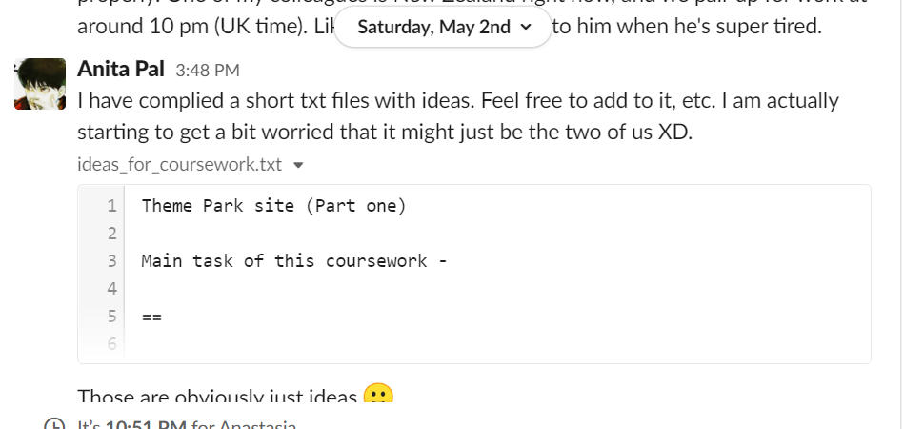

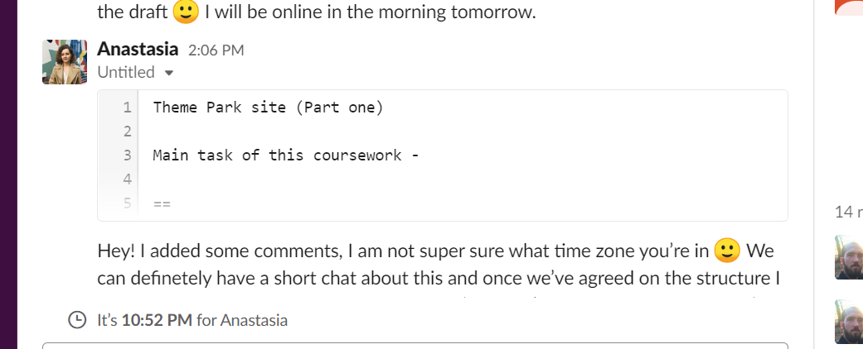

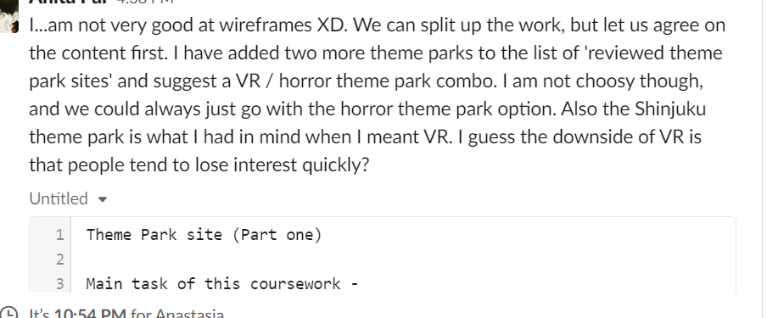

Once we were done with the initial discussion of what we wanted on our site, we decided to do the wireframes, the HTML and the CSS.

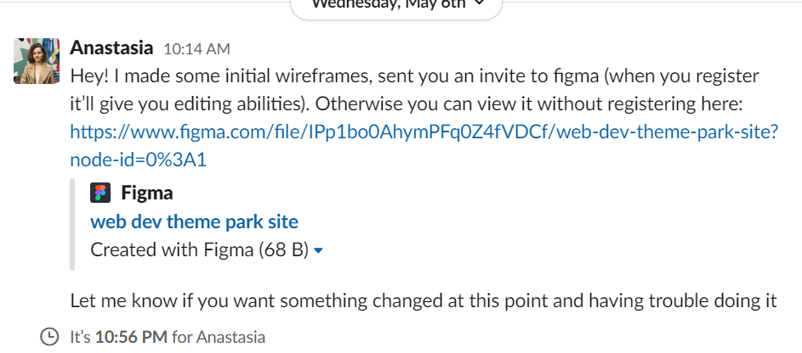

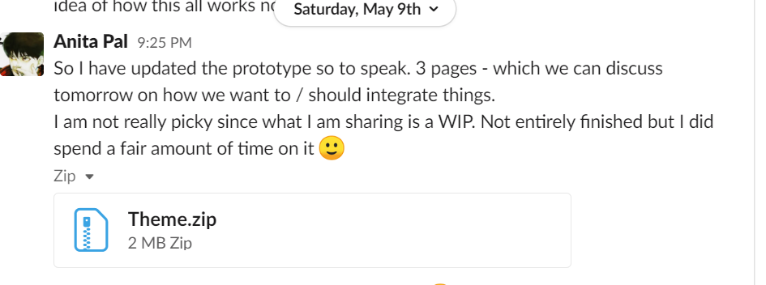

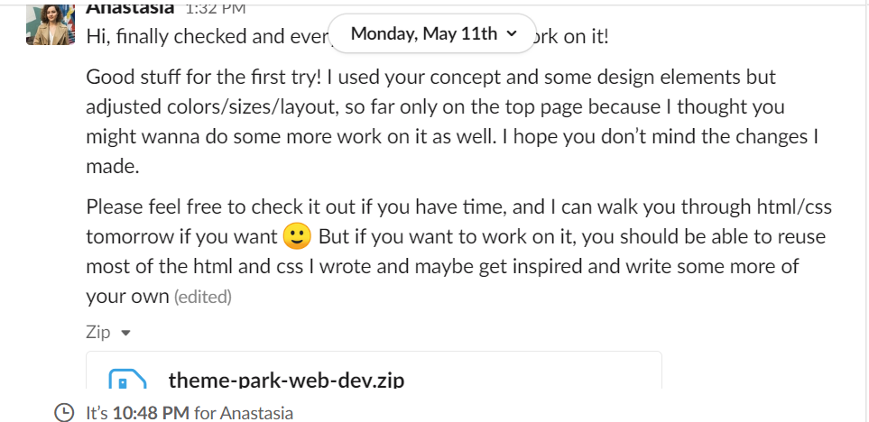

GitHub Organisation

The screenshot below depicts my personal repository where I started hosting the web development project as I worked across several laptops.

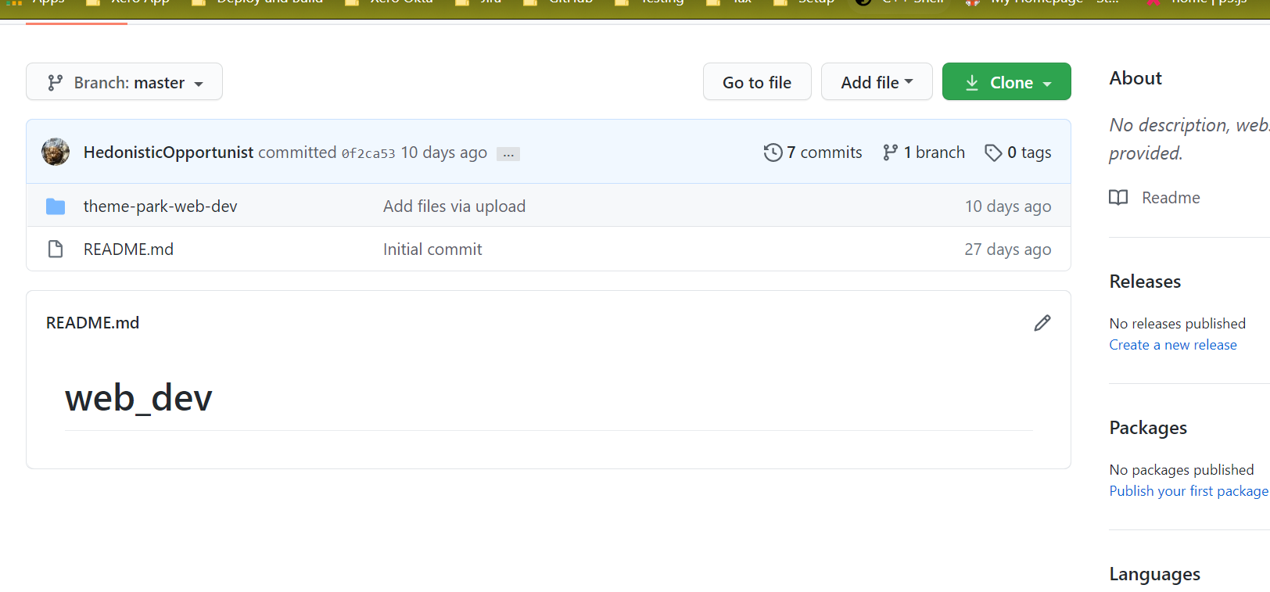

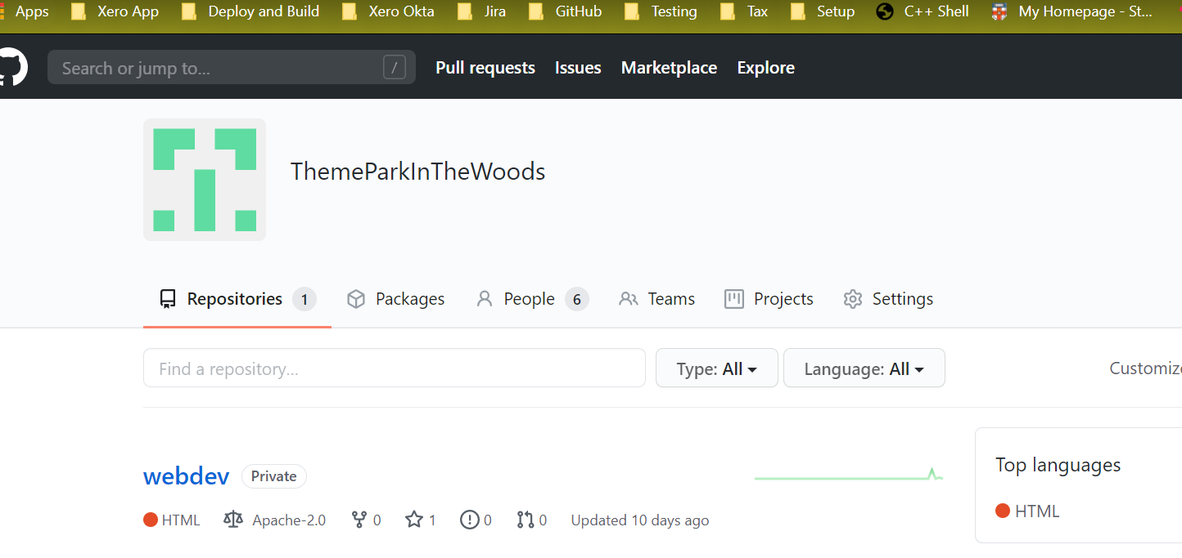

I decided to create an organisation once I realised that it was difficult to share code amongst team members otherwise. The further screenshots document how I sent out invitations to team members.

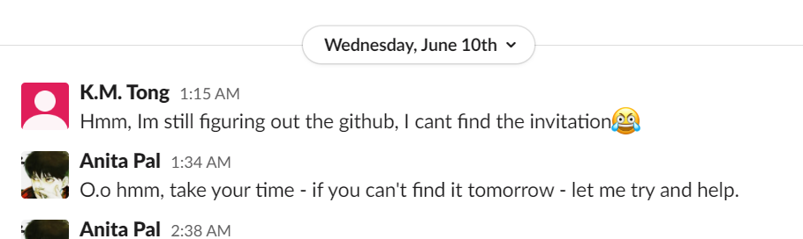

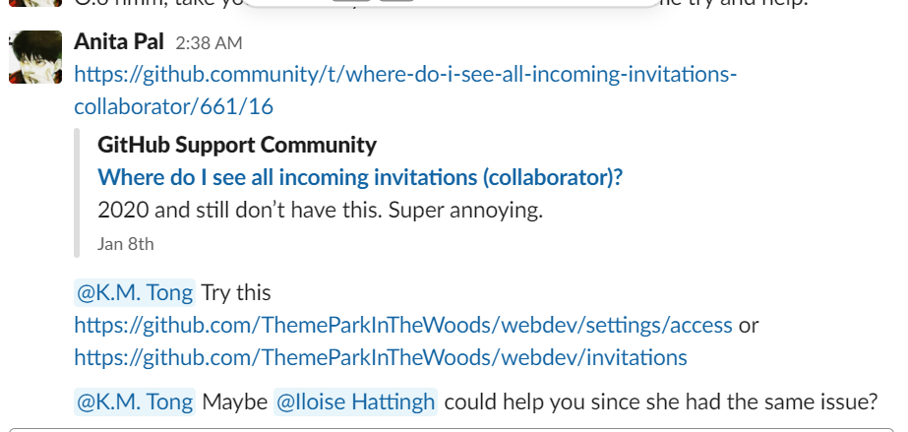

Regular submissions to the Slack channel:

These screenshots showcase the flow between me and the rest of the team. At the beginning, I was heavily active as I wanted the team to start working on the assignment quickly, so that we could have something fully functional by the end of June.

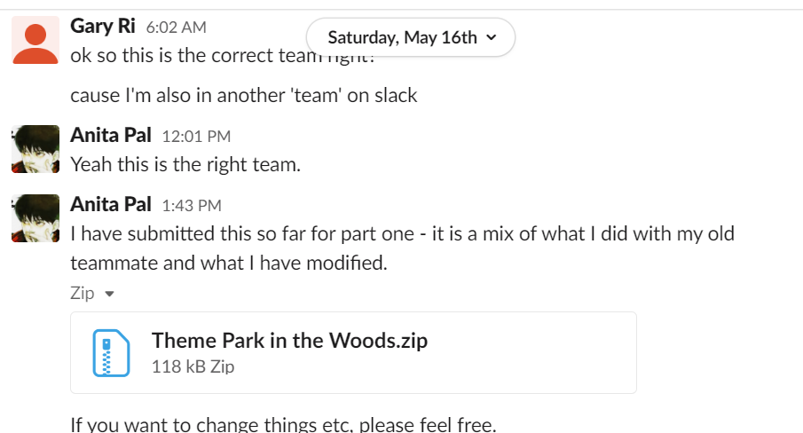

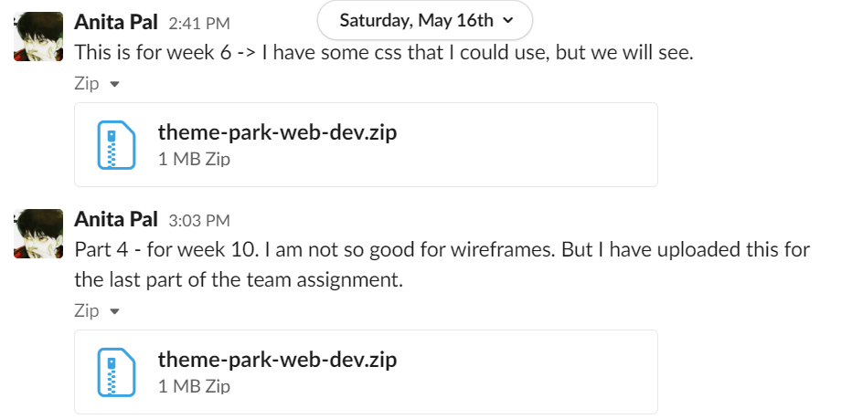

Iloise and Annie were both helpful and active when it came to the fleshing out of ideas for the website. They also helped with the wireframes.

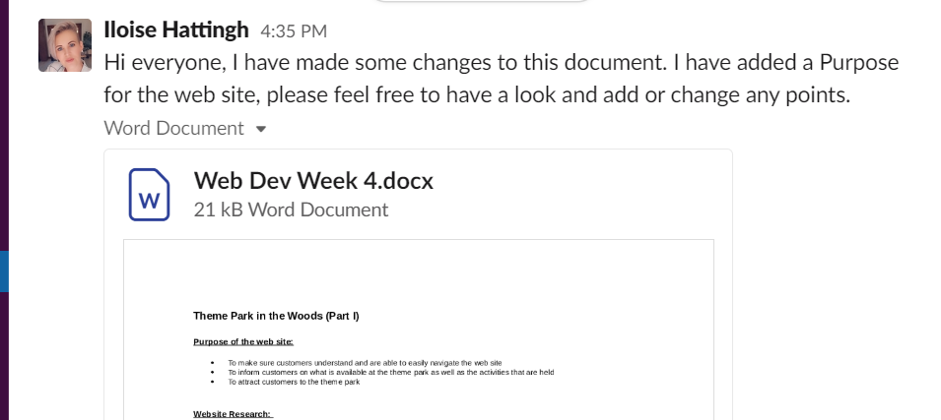

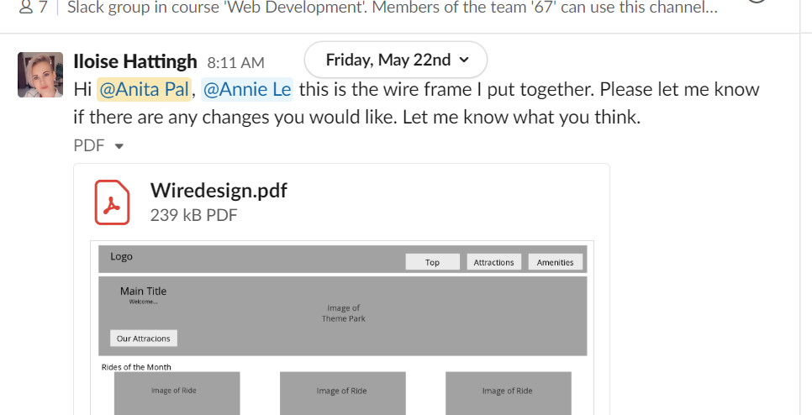

Annie came up with the idea for a map:

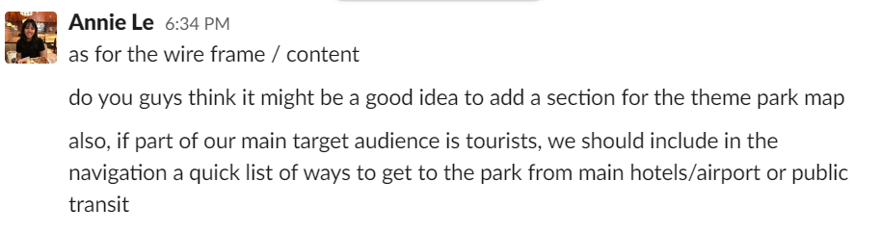

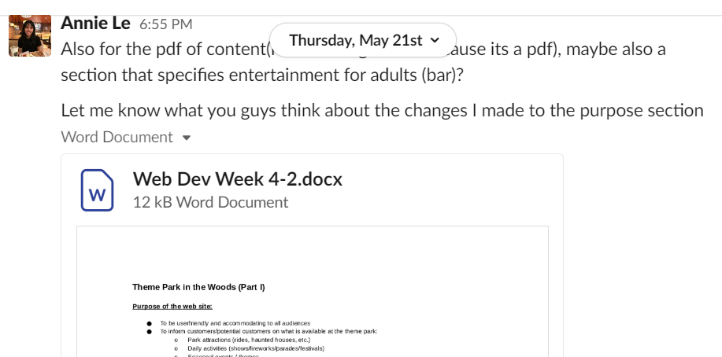

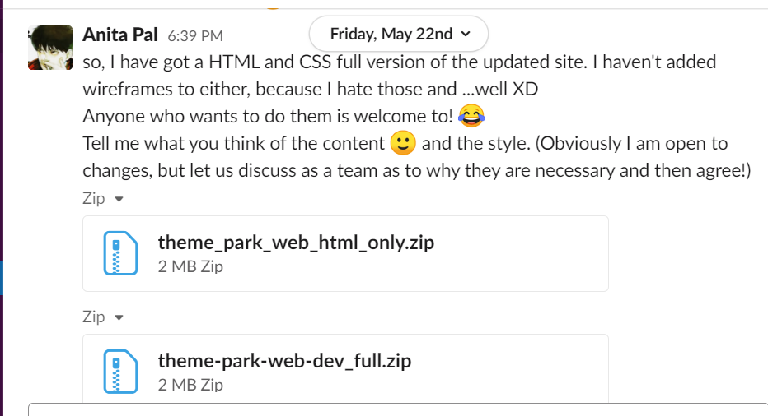

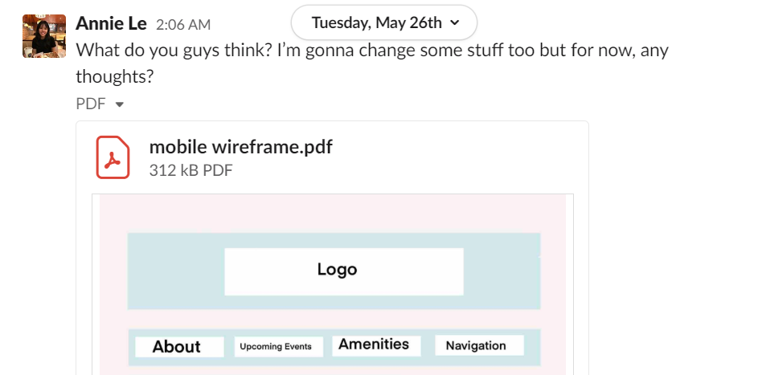

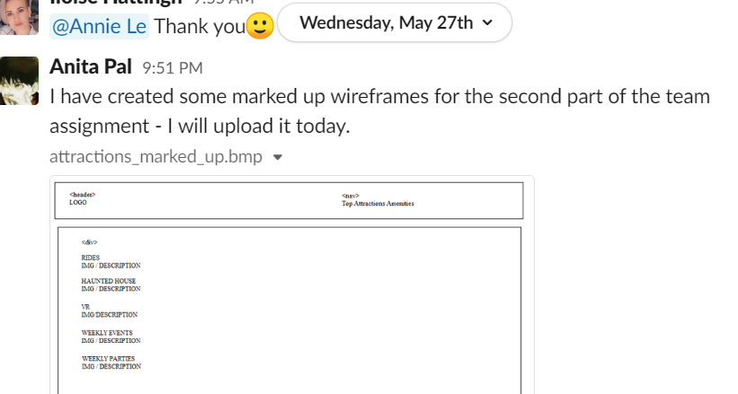

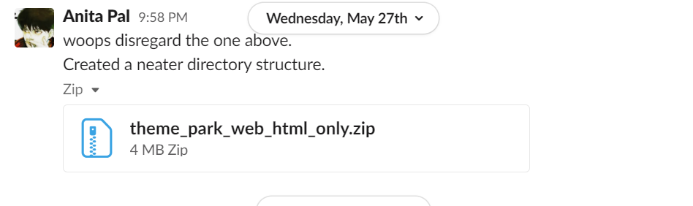

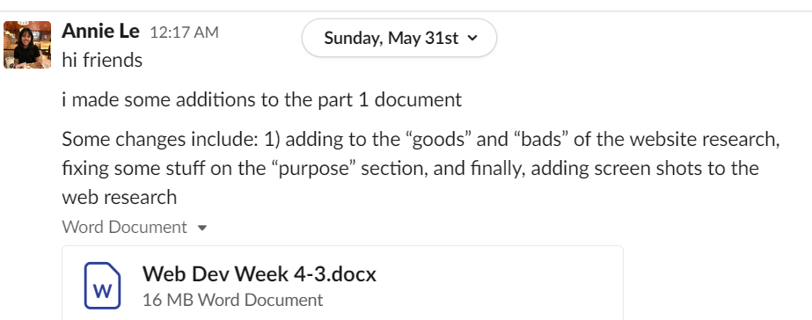

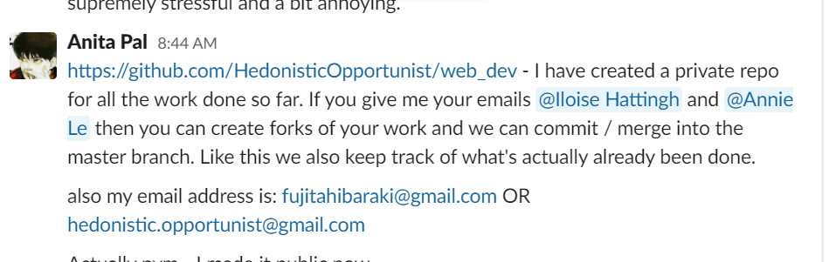

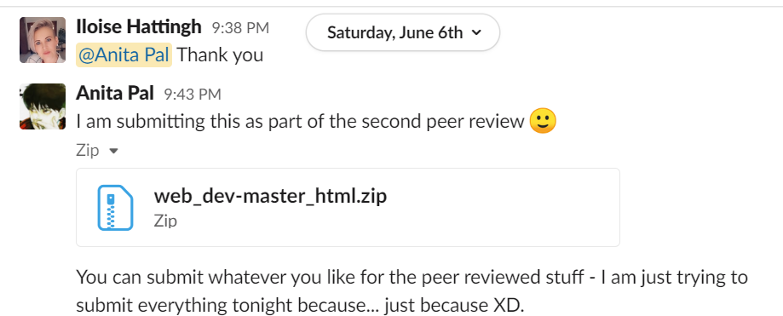

Will and K.M started organising the meetings:

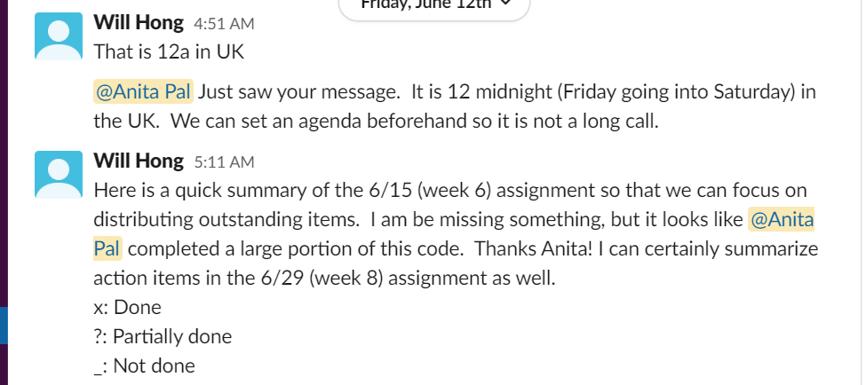

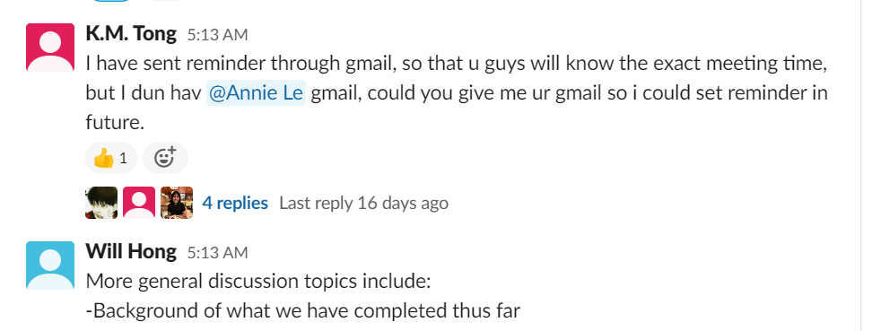

Gary mentioned that images were not working properly on the static website:

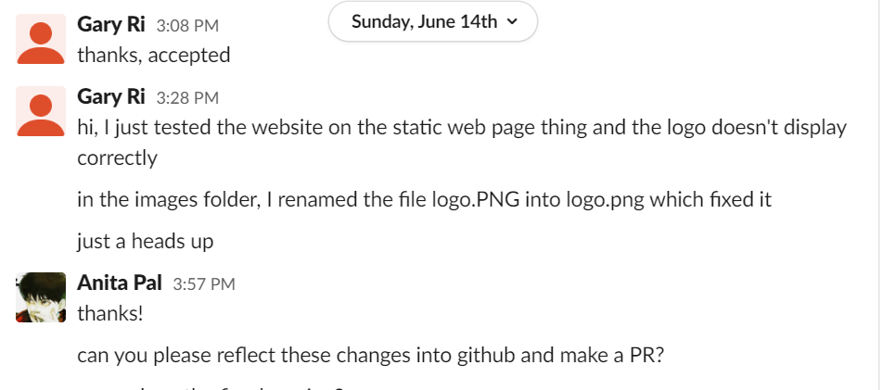

A message I posted on peer feedback re: the usage of CSS:

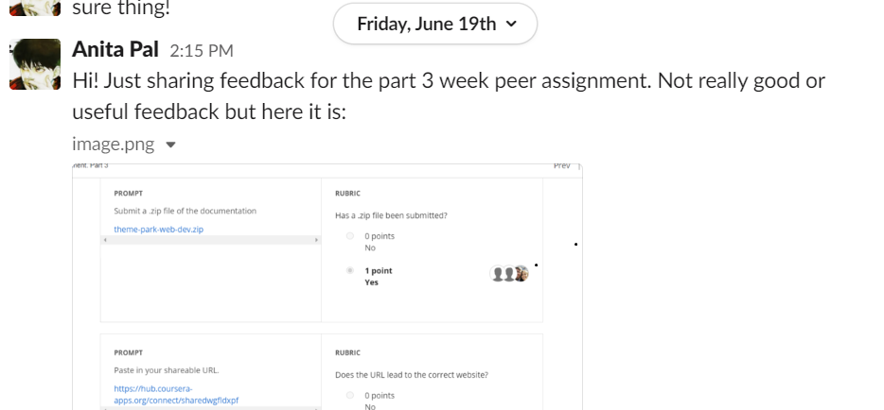

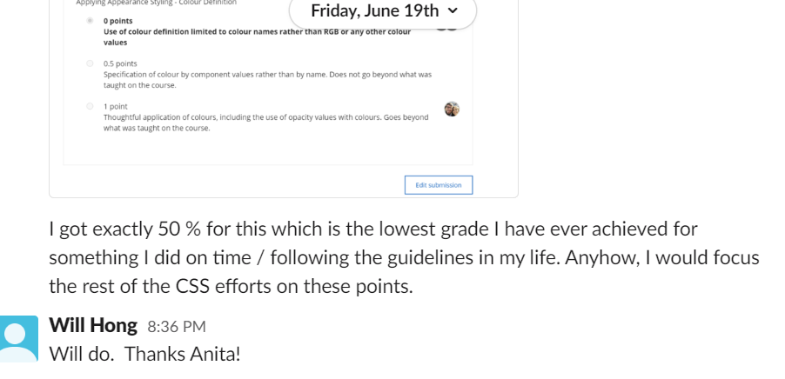

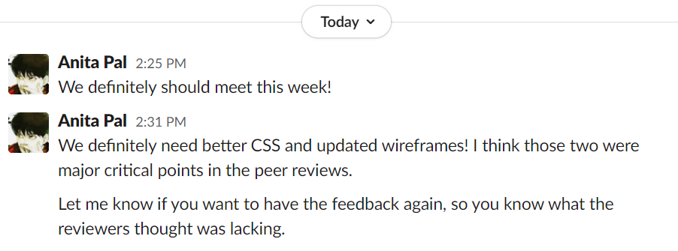

Will taking these ideas on board and improving upon the CSS:

